**MOOC Seminar Report**

**on**

**Computer Vision**

(CSE I Semester MOOC Seminar SCS-101)

2022-2023



**Submitted to: Submitted by:**

Ms. Deeksha Naithani Ms. Prerana

(CC-B.Tech. Section-A-I-Sem) Roll.No.:42

(B.Tech. Section**-A-**

I-Sem)

Session: 2022-2023

**Bachelor of Technology(B.Tech)**

**GRAPHIC ERA HILL UNIVERSITY,DEHRADUN**

**CERTIFICATE**

(from Internal Co-ordinator of MOOC i.e. Class Coordinator)

Certified that Ms. Prerana (Roll No.-42) have completed MOOC

Seminar on the topic “**MOOCS SEMINAR**” from NPTEL for

fulfillment of CSE I Semester MOOC Seminar SCS-101 in Graphic

Era Hill University,Dehradun. The student has successfully

completed this course to the best of my knowledge.

Date: 21 March 2022

Ms.Deeksha Naithani

**Class Coordinator**

**B.Tech. Section-A-I-Semester**

GEHU,Dehradun

**ACKNOWLEDGEMENT**

I would like to express our gratitude to the Almighty, the most

beneficent and the most merciful, for successful completion of

MOOC Seminar.

I wish to thank my parents for their continuing support and

encouragement. I also wish to thank them for providing me with

the opportunity to reach this far in our studies.

I also acknowledge to my class coordinator Ms.Deeksha

Naithani madam who helped me to understand this course.

At last but not the least, I greatly indebted to others who

directly or indirectly helped me during this course.

Ms. Prerana

Roll No-42

B. Tech. Section-A-I-Semester

Session:2022-2023

GEHU,Dehradun

**TABLE OF CONTENTS**

1. **INTRODUCTION**
   1. **C**omputerVision
   2. Applications of ComputerVision in real life
   3. History of Computer Vision
2. **TOPICS IN COMPUTER VISION**
   1. Image enhancements
   2. Color vision
   3. Feature extraction
   4. Registration
   5. Visual recognition
3. **PROBLEMS SOLVED BY COMPUTER VISION**
4. **IS COMPUTER VISION A PART OF ARTIFICIAL INTELLIGENCE**
5. **CONCLUSION**
   1. Summary
   2. Future works
   3. **INTRODUCTION**

1.1 COMPUTER VISION

Computer vision is a field of artificial intelligence (AI) that enables computers and systems to derive meaningful information from digital images, videos and other visual inputs — and take actions or make recommendations based on that information. If AI enables computers to think, computer vision enables them to see, observe and understand.

* 1. APPLICATION OF COMPUTER VISION IN REAL

LIFE

#### Facial Recognition

#### Augmented Reality

#### Social Distancing

#### Unmanned Aerial Vehicles (UAVs)

#### Machine Vision

#### Optical Character Recognition

#### Gesture Recognition

#### retinal-biometrics-technology-with-man-s-eye-digital-remix.jpg

* 1. HISTORY OF COMPUTER VISION

Scientists and engineers have been trying to develop ways for machines to see and understand visual data for about 60 years. Experimentation began in 1959 when neurophysiologists showed a cat an array of images, attempting to correlate a response in its brain. They discovered that it responded first to hard edges or lines, and scientifically, this meant that image processing starts with simple shapes like straight edges.

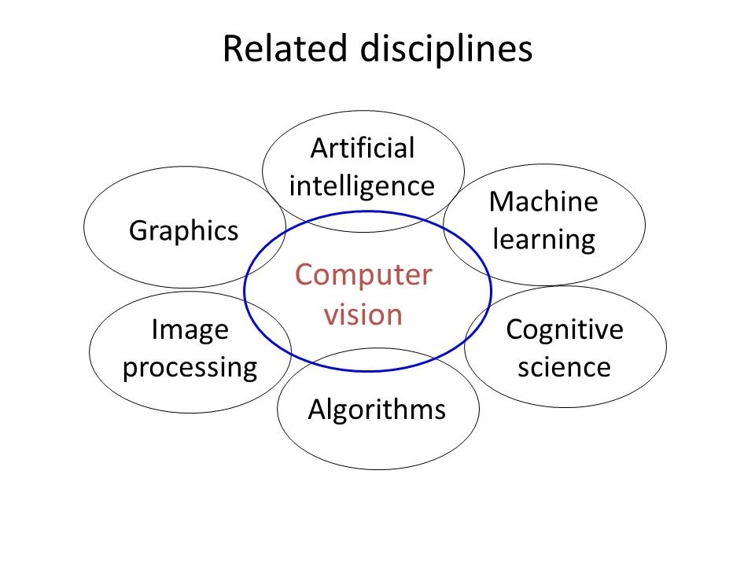

1. **TOPICS IN COMPUTER VISION**
   1. **IMAGE ENHANCEMENTS**

Image enhancement is the procedure of improving the quality and information content of original data before processing. Common practices include contrast enhancement, [spatial filtering](https://www.sciencedirect.com/topics/earth-and-planetary-sciences/spatial-filtering), density slicing, and FCC.

* 1. **COLOR VISION**

Coloris how our brain visually perceive the world. The color of an object is determined by the different wavelengths of light it reflects (and absorbs), which is affected by the object’s physical properties.Color is a perception, not the physical property of an object … though it’s affected by the object’s properties.

* 1. **FEATURE EXTRACTION**

Feature extraction refers to the process of transforming raw data into numerical features that can be processed while preserving the information in the original data set. It yields better results than applying machine learning directly to the raw data.

* 1. **REGISTRATION**

It is used in computer vision, medical imaging, military automatic target recognition, and compiling and analyzing images and data from satellites. Registration is necessary in order to be able to compare or integrate the data obtained from these different measurements.

* 1. **VISUAL RECOGNITION**

Image recognition, in the context of machine vision, is the ability of software to identify objects, places, people, writing and actions inimages. Computers can use machine vision technologies in combination with a camera and artificial intelligence software to achieve image recognition.

1. **PROBLEMS SOLVED BY COMPUTER VISION**

The current level of computer vision allows the detection and tracking of single objects (faces, pedestrians, cars) classes in an unconstrained setting. It enables the realization of smart cameras to identify smiling persons, pedestrian detection, surveillance applications, including image-based web servers.

1. ENFORCING WORKPLACE SAFETy
2. MEASURING IMMUNITY CELLS IN CANCER PATIENTS
3. ANALYZING X-RAYS FOR COVID-19 SYMPTOMS
4. USING DRONE IMAGERY FOR INSURANCE CLAIMS
5. FINDING DEFECTS IN RAILROAD TRACKS
6. **is computer vision a part of artificial intelligence**

**Computer vision is a field of AI** that trains computers to capture and interpret information from image and video data. By applying machine learning (ML) models to images, computers can classify objects and respond—like unlocking your smartphone when it recognizes your face.

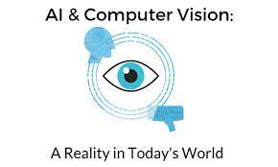

1. **CONCLUSION**

**5.1 SUMMARY**

Computer Vision is a very active research field with many practical applications, for instance in quality control, robotics, or driver assistance systems. The goal of Computer Vision is to imitate the flexibility and robustness of the human visual system. Research has made significant progress in recent years particularly due to deep learning. Almost all research in Computer Vision has shifted to deep learning based methods.

**5.2 FUTURE WORKS**

With further research on and refinement of the technology, the future of computer vision will see it perform a broader range of functions. Not only will computer vision technologies be easier to train but also be able to discern more from images than they do now.



Computer vision is among the most progressive and rapidly growing fields. According to Grand View Research, the global computer vision market size was valued at $11.32 billion in 2020 and is **expected to expand at a compound annual growth rate of 7.3% from 2021 to 2028**.

**REFERENCES**

* 1. Ballard, Dana H. and Christopher M. Brown (1982) Computer Vision, Prentice-Hall, Englewood Cliffs NJ .
  2. Davies, E.R. (1997) Machine Vision: Theory, Algorithm, Practicalities (2nd edition), Academic Press, San Diego.
  3. Haralick, Robert M. and Linda G. Shapiro (1992-93) Computer and Robot Vision (2 volumes), Addison-Wesley, Reading MA (ISBN 0-201-10877-1 and 0-201-56943-4).
  4. Horn, Berthold K.P. (1986) Robot Vision, MIT Press, Cambridge MA .
  5. Jain, Ramesh, Rangachar Kasturi, and Brian G. Schunck (1995) McGraw-Hill, New York (ISBN 0-07-032018-7).

1. Nalwa, Vishvjit (1993) A Guided Tour of Computer Vision, Addison-Wesley, Reading MA.